[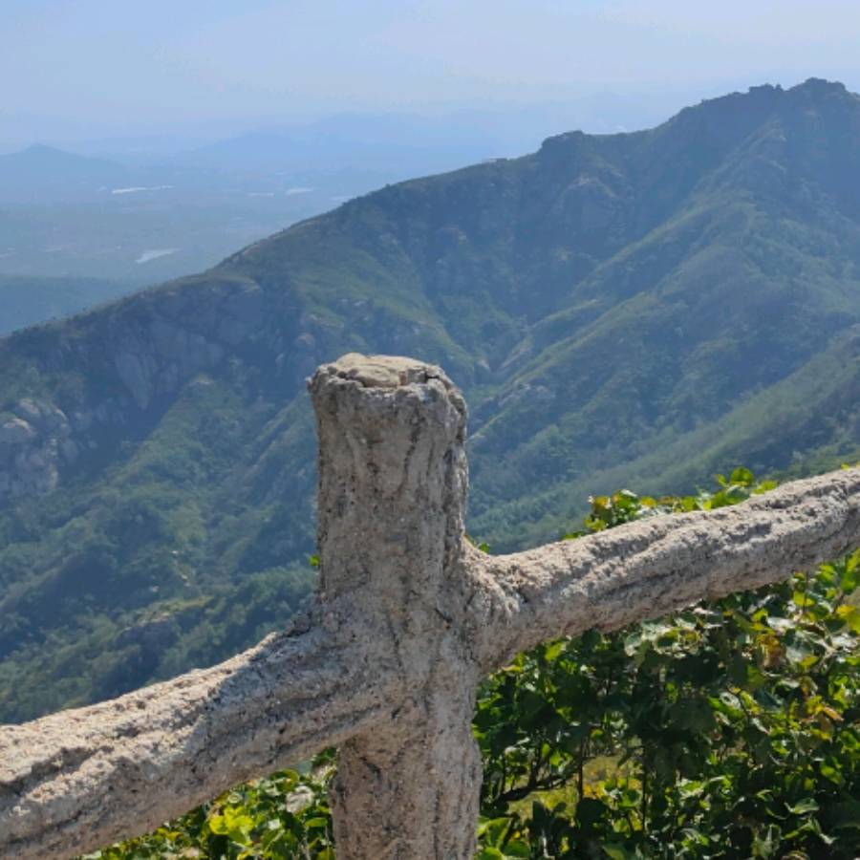](http://mp.sohu.com/profile?xpt=ZGY2MzcwMDYtYjEzNC00ODgyLThiZjEtNmRmNGE1YTYzOWE4&spm=smpc.content-abroad.fd-d.2.1674759585878nV5uGqQ)

[](http://mp.sohu.com/profile?xpt=MDdjNDVhYTktMGQ0My00YzFkLWEwYzgtZDU1MjAxNTk1MzZh&spm=smpc.content-abroad.fd-d.3.1674759585878nV5uGqQ)

[](https://ssxd.mediav.com/s?type=2&r=20&mv_ref=www.sohu.com&enup=CAAByc6/NggAAja/zskA&mvid=NDcxODg5MDE2MTc1MDAzMTIwMTAwMjM&bid=171d8a8a53efb28f&price=AAAAAGPSzakAAAAAAA2XDCF5Dqdpv7IptrF6dw==&finfo=DAABCAABAAAATggAAgAAAI0EAAM/Qgl3HaLDogAIAAIAAAADCgADe2p/IzCeoEYIAAQAAACNBgAGHgMGAAoAAAgADgAAABYKAA8AAAAAAAvm4AgAEgAAADUA&ugi=FYbKDRW6wT5MFfgGFQAVABUAABWAw6CuBBYEFcgBFoDx/6nry/kFHBat4b+qqrv8uJkBFQAAJYq48q0KEgA&uai=FeyJngIlAhUEFtqJncLrgrvq9gEV8gglqZyrwQwUFBUAFRoUABwWo9eNkKDp3YffARUAAAA&ubi=FeqFigEV4sfmAxXA37YdFfSTp2IVBhUiFoiAs+YYFtqJsqn1yL/q9gE0Ahag4JCAwAIlBhXtps/wBhWcARUAJBQW88yHvoTi+7MRFQAl4LkBFeIEFQwVAhcAAACgkUmav0gBAAA&clickid=103081210001&cpx=__OFFSET_X__&cpy=__OFFSET_Y__&cs=__EVENT_TIME_START__&ce=__EVENT_TIME_END__&adsw=__ADSPACE_W__&adsh=__ADSPACE_H__&ldtype=2&csign2=mS9QWpNTlK-=&url=https%3A%2F%2Fshark-tracer.netease.com%2Fv1%2Flog%2Fdefault%3Fproject_id%3D103728761%26sign%3DdCnqjqxCkzaL2eg6gMWBZ3iwgK5pouC5%26log_type%3Dcloud_click%26sourceid%3D%7Bsource_id%7D)

[](https://ssxd.mediav.com/s?type=2&r=20&mv_ref=www.sohu.com&enup=CAAByc6/NggAAja/zskA&mvid=NDcxODg5MDE2MTc1MDAzMTIwMTAwMjM&bid=171d8a8a53efb28f&price=AAAAAGPSzakAAAAAAA2XDCF5Dqdpv7IptrF6dw==&finfo=DAABCAABAAAATggAAgAAAI0EAAM/Qgl3HaLDogAIAAIAAAADCgADe2p/IzCeoEYIAAQAAACNBgAGHgMGAAoAAAgADgAAABYKAA8AAAAAAAvm4AgAEgAAADUA&ugi=FYbKDRW6wT5MFfgGFQAVABUAABWAw6CuBBYEFcgBFoDx/6nry/kFHBat4b+qqrv8uJkBFQAAJYq48q0KEgA&uai=FeyJngIlAhUEFtqJncLrgrvq9gEV8gglqZyrwQwUFBUAFRoUABwWo9eNkKDp3YffARUAAAA&ubi=FeqFigEV4sfmAxXA37YdFfSTp2IVBhUiFoiAs+YYFtqJsqn1yL/q9gE0Ahag4JCAwAIlBhXtps/wBhWcARUAJBQW88yHvoTi+7MRFQAl4LkBFeIEFQwVAhcAAACgkUmav0gBAAA&clickid=103081210002&cpx=__OFFSET_X__&cpy=__OFFSET_Y__&cs=__EVENT_TIME_START__&ce=__EVENT_TIME_END__&adsw=__ADSPACE_W__&adsh=__ADSPACE_H__&ldtype=2&csign2=mS9QWpNTlK-=&url=https%3A%2F%2Fshark-tracer.netease.com%2Fv1%2Flog%2Fdefault%3Fproject_id%3D103728761%26sign%3DdCnqjqxCkzaL2eg6gMWBZ3iwgK5pouC5%26log_type%3Dcloud_click%26sourceid%3D%7Bsource_id%7D)

[](https://ssxd.mediav.com/s?type=2&r=20&mv_ref=www.sohu.com&enup=CAAByc6/NggAAja/zskA&mvid=NDcxODg5MDE2MTc1MDAzMTIwMTAwMjM&bid=171d8a8a53efb28f&price=AAAAAGPSzakAAAAAAA2XDCF5Dqdpv7IptrF6dw==&finfo=DAABCAABAAAATggAAgAAAI0EAAM/Qgl3HaLDogAIAAIAAAADCgADe2p/IzCeoEYIAAQAAACNBgAGHgMGAAoAAAgADgAAABYKAA8AAAAAAAvm4AgAEgAAADUA&ugi=FYbKDRW6wT5MFfgGFQAVABUAABWAw6CuBBYEFcgBFoDx/6nry/kFHBat4b+qqrv8uJkBFQAAJYq48q0KEgA&uai=FeyJngIlAhUEFtqJncLrgrvq9gEV8gglqZyrwQwUFBUAFRoUABwWo9eNkKDp3YffARUAAAA&ubi=FeqFigEV4sfmAxXA37YdFfSTp2IVBhUiFoiAs+YYFtqJsqn1yL/q9gE0Ahag4JCAwAIlBhXtps/wBhWcARUAJBQW88yHvoTi+7MRFQAl4LkBFeIEFQwVAhcAAACgkUmav0gBAAA&clickid=103081210003&cpx=__OFFSET_X__&cpy=__OFFSET_Y__&cs=__EVENT_TIME_START__&ce=__EVENT_TIME_END__&adsw=__ADSPACE_W__&adsh=__ADSPACE_H__&ldtype=2&csign2=mS9QWpNTlK-=&url=https%3A%2F%2Fshark-tracer.netease.com%2Fv1%2Flog%2Fdefault%3Fproject_id%3D103728761%26sign%3DdCnqjqxCkzaL2eg6gMWBZ3iwgK5pouC5%26log_type%3Dcloud_click%26sourceid%3D%7Bsource_id%7D)

[](https://ssxd.mediav.com/s?type=2&r=20&mv_ref=www.sohu.com&enup=CAAByc6/NggAAja/zskA&mvid=NDcxODg5MDE2MTc1MDAzMTIwMTAwMjM&bid=171d8a8a53efb28f&price=AAAAAGPSzakAAAAAAA2XDCF5Dqdpv7IptrF6dw==&finfo=DAABCAABAAAATggAAgAAAI0EAAM/Qgl3HaLDogAIAAIAAAADCgADe2p/IzCeoEYIAAQAAACNBgAGHgMGAAoAAAgADgAAABYKAA8AAAAAAAvm4AgAEgAAADUA&ugi=FYbKDRW6wT5MFfgGFQAVABUAABWAw6CuBBYEFcgBFoDx/6nry/kFHBat4b+qqrv8uJkBFQAAJYq48q0KEgA&uai=FeyJngIlAhUEFtqJncLrgrvq9gEV8gglqZyrwQwUFBUAFRoUABwWo9eNkKDp3YffARUAAAA&ubi=FeqFigEV4sfmAxXA37YdFfSTp2IVBhUiFoiAs+YYFtqJsqn1yL/q9gE0Ahag4JCAwAIlBhXtps/wBhWcARUAJBQW88yHvoTi+7MRFQAl4LkBFeIEFQwVAhcAAACgkUmav0gBAAA&clickid=103081210004&cpx=__OFFSET_X__&cpy=__OFFSET_Y__&cs=__EVENT_TIME_START__&ce=__EVENT_TIME_END__&adsw=__ADSPACE_W__&adsh=__ADSPACE_H__&ldtype=2&csign2=mS9QWpNTlK-=&url=https%3A%2F%2Fshark-tracer.netease.com%2Fv1%2Flog%2Fdefault%3Fproject_id%3D103728761%26sign%3DdCnqjqxCkzaL2eg6gMWBZ3iwgK5pouC5%26log_type%3Dcloud_click%26sourceid%3D%7Bsource_id%7D)

[](http://mp.sohu.com/profile?xpt=MWY2N2Q3OGQtZjg0NC00MThhLWE4MjItY2Y0M2QyYmJkMzE4&spm=smpc.content-abroad.fd-d.5.1674759585878nV5uGqQ)

[](http://mp.sohu.com/profile?xpt=ZTI5MmYxNzEtNTI1NS00MGUxLWFjYTUtMzJmOTEzOTY1ZDAx&spm=smpc.content-abroad.fd-d.8.1674759585878nV5uGqQ)

[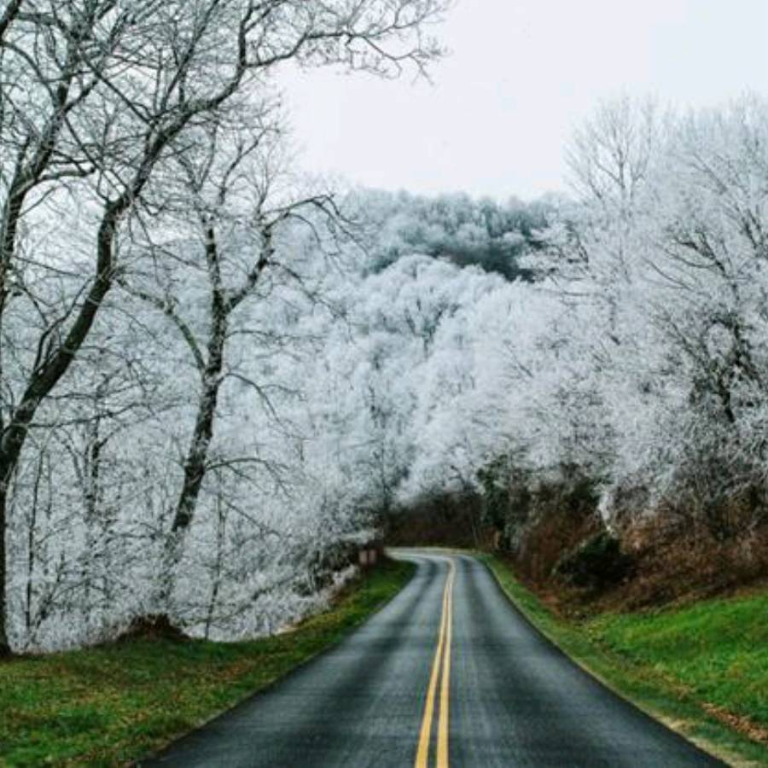](http://mp.sohu.com/profile?xpt=ODhiZWRjYzQtNTk1NC00MGJlLTg0MWItZTM2YWNlN2FiNzRl&spm=smpc.content-abroad.fd-d.9.1674759585878nV5uGqQ)

[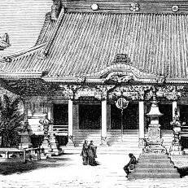](http://mp.sohu.com/profile?xpt=YWEwYWVkMjYtOWY4YS00MzE5LTkxZjktZWRhYWUxNTAyZjkw&spm=smpc.content-abroad.fd-d.10.1674759585878nV5uGqQ)

[](http://mp.sohu.com/profile?xpt=YTM1ZDFkMWYtMWY5OS00ZjljLTk0NTgtMDRkMjc0MjljZjc0&spm=smpc.content-abroad.fd-d.11.1674759585878nV5uGqQ)

[](http://mp.sohu.com/profile?xpt=NjYwYzFkMGItMWUyZS00NjUxLTkwOGEtN2FhNDI0ZTczMTRl&spm=smpc.content-abroad.fd-d.12.1674759585878nV5uGqQ)

[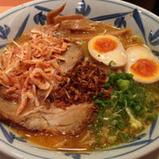](http://mp.sohu.com/profile?xpt=ODRkMDM4MGYtZTRiYy00NGI2LWJlZGUtZTk0MzRiZTZlNDVi&spm=smpc.content-abroad.fd-d.13.1674759585878nV5uGqQ)

[](http://mp.sohu.com/profile?xpt=MTAzNjAyOTczMzczNTA1NTM2MEBzb2h1LmNvbQ==&spm=smpc.content-abroad.fd-d.14.1674759585878nV5uGqQ)

[](http://mp.sohu.com/profile?xpt=N2RiZTM5NDYtOTRiZS00NDg0LWE4MDUtZTRmNWZmYmY0MjU0&spm=smpc.content-abroad.fd-d.15.1674759585878nV5uGqQ)

[](http://mp.sohu.com/profile?xpt=NjYyOGYxODMtYzg5OC00ZWJjLTg2ZjgtYjA5OGY4MDNkOWM0&spm=smpc.content-abroad.fd-d.16.1674759585878nV5uGqQ)

[](http://mp.sohu.com/profile?xpt=OTc5NTgwMzQwOTU3OTAwODAwQHNvaHUuY29t&spm=smpc.content-abroad.fd-d.17.1674759585878nV5uGqQ)

[](http://mp.sohu.com/profile?xpt=YzJlZWZmMzYtMWVhZC00ZDJhLTlhZTItNWMxZjVmZDI3NTY0&spm=smpc.content-abroad.fd-d.18.1674759585878nV5uGqQ)

[](http://mp.sohu.com/profile?xpt=YzFkYjI0OWYtN2I5Ni00YTU0LTk2YjktYTE4YTBlMmJmMzY2&spm=smpc.content-abroad.fd-d.19.1674759585878nV5uGqQ)

[](http://mp.sohu.com/profile?xpt=MWZmZTJkMmMtZDY3Ni00MzkwLTg4MTAtMTYwYjZkZmQwMDlj&spm=smpc.content-abroad.fd-d.20.1674759585878nV5uGqQ)

[](http://mp.sohu.com/profile?xpt=YjI3ODQyMzctMGEzZC00MmFhLTlmMjctM2RkYTMwZGVlYWZk&spm=smpc.content-abroad.fd-d.21.1674759585878nV5uGqQ)

[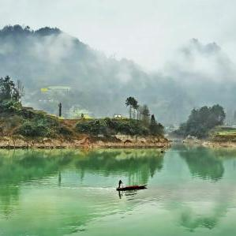](http://mp.sohu.com/profile?xpt=OGMxNzBkY2EtYzkzYy00ZWQwLTk2NjAtOGNjM2NjYmIzNWRl&spm=smpc.content-abroad.fd-d.22.1674759585878nV5uGqQ)

[](http://mp.sohu.com/profile?xpt=MzE3YjBjNjMtZWIzYi00OWY1LThiYzMtMTdjYjQ4NmY3ZWEy&spm=smpc.content-abroad.fd-d.23.1674759585878nV5uGqQ)

[](http://mp.sohu.com/profile?xpt=ZjQ1ZTQ4MzYtM2ZlNS00NWUzLWExM2EtNDViNDI1ODI5N2M5&spm=smpc.content-abroad.fd-d.26.1674759585878nV5uGqQ)

[](http://mp.sohu.com/profile?xpt=MTAxNjY5NTEwNzI0NTc3MjgwMEBzb2h1LmNvbQ==&spm=smpc.content-abroad.fd-d.27.1674759585878nV5uGqQ)

[](http://mp.sohu.com/profile?xpt=ZjBjNzc2MWUtMmRlZS00ODY4LTliYWMtOWZmODNkNGMyMGMw&spm=smpc.content-abroad.fd-d.29.1674759585878nV5uGqQ)

[](http://mp.sohu.com/profile?xpt=ZmFjY2E5YTctZWM1Zi00NTE3LWFmYTgtZmM4NDQzMjFiNTgw&spm=smpc.content-abroad.fd-d.30.1674759585878nV5uGqQ)

[](http://mp.sohu.com/profile?xpt=YTU3MDZlNGEtZWUxZC00M2UyLTg1NzYtOTYxMmQ2NWQyMWE0&spm=smpc.content-abroad.fd-d.33.1674759585878nV5uGqQ)

[](http://mp.sohu.com/profile?xpt=NDY4MjY4YmYtYzI0ZC00NjQxLWE4YmMtNTY4NzkxMDJlYjVl&spm=smpc.content-abroad.fd-d.34.1674759585878nV5uGqQ)

[](http://mp.sohu.com/profile?xpt=YjgwNDM4Y2MtYWQ0Zi00MjgyLTg2MTYtNzBlNWE4NTA5MWFh&spm=smpc.content-abroad.fd-d.35.1674759585878nV5uGqQ)

[](http://mp.sohu.com/profile?xpt=NGFhOGRkYjUtZmMyYi00MTNjLWI1M2UtZjJlMDkwOTdlMTgy&spm=smpc.content-abroad.fd-d.37.1674759585878nV5uGqQ)

[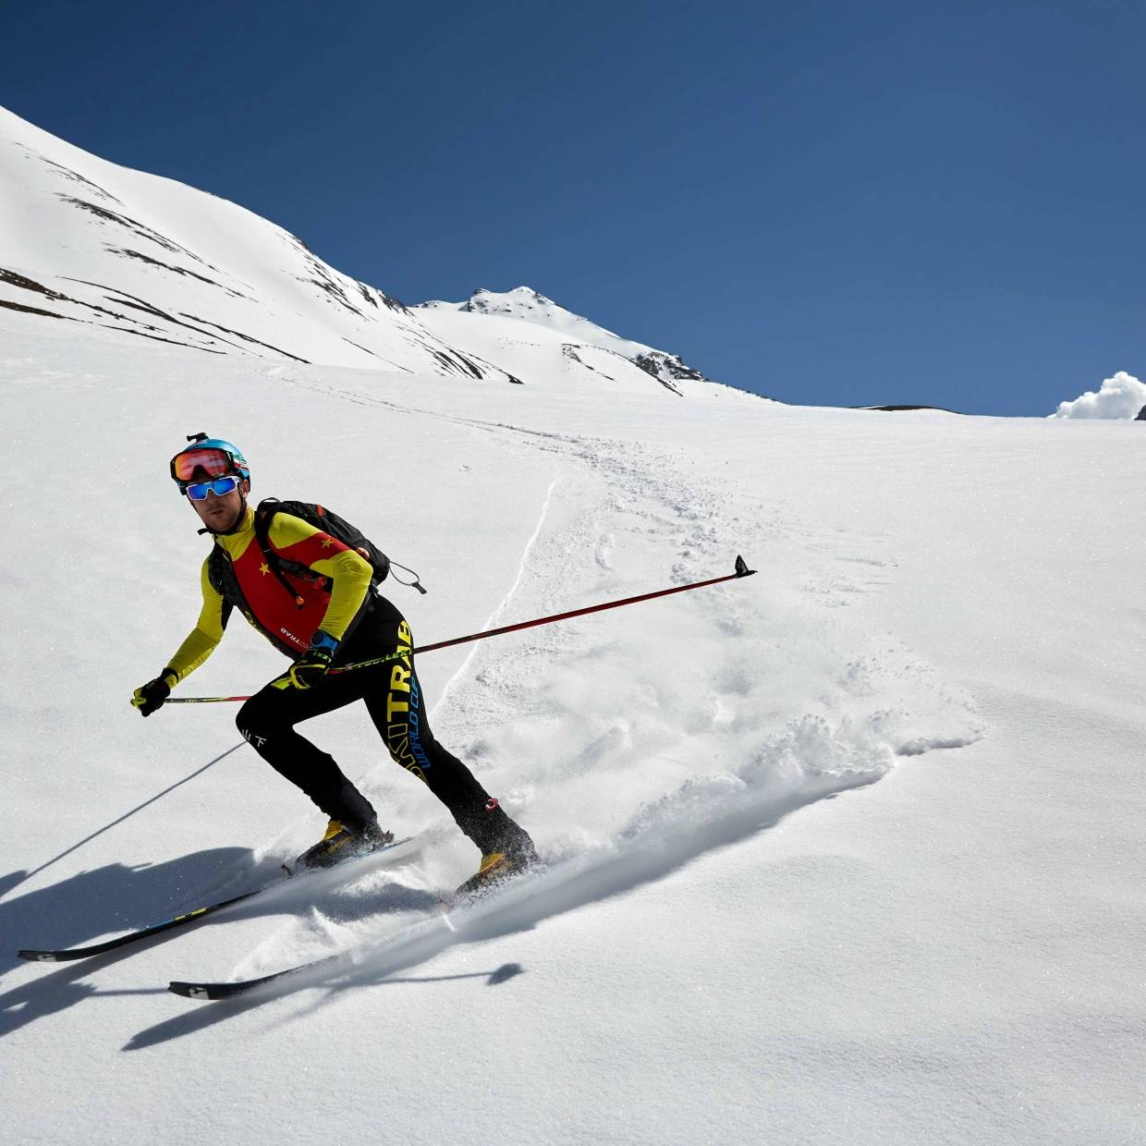](http://mp.sohu.com/profile?xpt=ODBjNDI2NjQtMDY5MS00NzU4LWFkZDYtZTk0ZjcwNmU5NTVl&spm=smpc.content-abroad.fd-d.38.1674759585878nV5uGqQ)

[](http://mp.sohu.com/profile?xpt=cHBhZzg2NzE4ZjUwMzU2Y0Bzb2h1LmNvbQ==&spm=smpc.content-abroad.fd-d.39.1674759585878nV5uGqQ)

[](http://mp.sohu.com/profile?xpt=NmVjMjMzMjMtNGRkYy00OGE1LThhOTEtMzIxZGJlNDI5ZDg2&spm=smpc.content-abroad.fd-d.40.1674759585878nV5uGqQ)

[](http://mp.sohu.com/profile?xpt=YzA5YTUyMzYtMmVjOC00ZWE1LWE4MjctZTM3ZTE0ODdjMWRk&spm=smpc.content-abroad.fd-d.42.1674759585878nV5uGqQ)

[](http://mp.sohu.com/profile?xpt=NGY1M2NhNjctMjFiYi00ZDRmLWFmNmQtOTBkOTU5NDg3MzBm&spm=smpc.content-abroad.fd-d.43.1674759585878nV5uGqQ)

[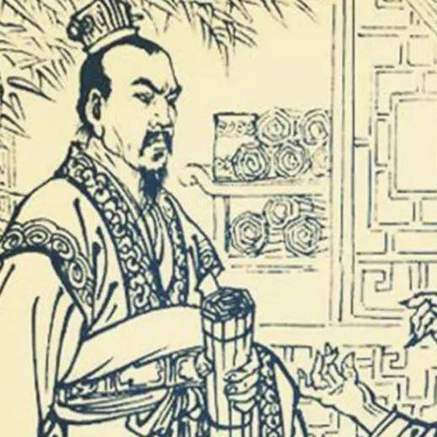](http://mp.sohu.com/profile?xpt=ZDIwYTQ3MTQtODRlNy00ZTY4LWEwNTYtOTU1ZGIzNzI4MTM0&spm=smpc.content-abroad.fd-d.44.1674759585878nV5uGqQ)

[](http://mp.sohu.com/profile?xpt=MjI4ZmU5NTktZTRmYy00OGM2LWI4OTktM2YwNWY5OWM2Mjk2&spm=smpc.content-abroad.fd-d.46.1674759585878nV5uGqQ)

[](http://mp.sohu.com/profile?xpt=ZTg2M2JmY2MtNjMzZS00NTZkLWFiZmQtNzFlNzkxYjA1ZTE0&spm=smpc.content-abroad.fd-d.47.1674759585878nV5uGqQ)

[](http://mp.sohu.com/profile?xpt=ODA0ZWRjZjktYWZkZC00ZDM1LWEwYjMtYTgzNjBlNmIxZGM4&spm=smpc.content-abroad.fd-d.48.1674759585878nV5uGqQ)

[](http://mp.sohu.com/profile?xpt=NjlmOWMyYjAtYzA1Ni00NDMzLTg2ZWQtYzM1Y2ZmODEyZTRi&spm=smpc.content-abroad.fd-d.49.1674759585878nV5uGqQ)

[](http://mp.sohu.com/profile?xpt=cHBhZzgyMDA5ZDg5OTAyMEBzb2h1LmNvbQ==&spm=smpc.content-abroad.fd-d.50.1674759585878nV5uGqQ)

[](http://mp.sohu.com/profile?xpt=ZGY0ZDhjMWYtNzQ4Ni00ZjBmLTgwZWUtNDg2NWZjNDU5N2U2&spm=smpc.content-abroad.fd-d.51.1674759585878nV5uGqQ)

2[](http://mp.sohu.com/profile?xpt=NDNjZTlhYWEtZjlmOS00MWI3LTgwODctOTc0MmJhOTQ1ZDM2&spm=smpc.content-abroad.fd-d.52.1674759585878nV5uGqQ)

[](http://mp.sohu.com/profile?xpt=ZTg1ODNjMmQtZTYwMS00MTViLThjYTctOWY0MTZkMWM1YTli&spm=smpc.content-abroad.fd-d.53.1674759585878nV5uGqQ)

[](http://mp.sohu.com/profile?xpt=NGY1M2NhNjctMjFiYi00ZDRmLWFmNmQtOTBkOTU5NDg3MzBm&spm=smpc.content-abroad.fd-d.54.1674759585878nV5uGqQ)

[](http://mp.sohu.com/profile?xpt=MTdiYzQ4NDMtYTMyNC00YWE3LTk3YTMtZGQ4NWZhODEwYzVk&spm=smpc.content-abroad.fd-d.56.1674759585878nV5uGqQ)

[](http://mp.sohu.com/profile?xpt=YTRjMjRjNTMtYjBkMy00Yzk1LWE3YmMtZjZmZDYzZmI5ZWY0&spm=smpc.content-abroad.fd-d.57.1674759585878nV5uGqQ)

[](http://mp.sohu.com/profile?xpt=MGY1MWJkMTUtMTZhMS00NWYzLWJhMjgtZWU4ZGFjZmNiMGYz&spm=smpc.content-abroad.fd-d.58.1674759585878nV5uGqQ)

[](http://mp.sohu.com/profile?xpt=ZDRjMDk2NjYtMTBkYy00YjdlLWExOGQtMTVlNjhkYWNmM2Vh&spm=smpc.content-abroad.fd-d.59.1674759585878nV5uGqQ)

[](http://mp.sohu.com/profile?xpt=Y2NlODdiZGItODljOC00NGU5LWIxZmMtMjVkZTkwODRjYjI5&spm=smpc.content-abroad.fd-d.61.1674759585878nV5uGqQ)

[](http://mp.sohu.com/profile?xpt=MDY2MTZkZjItOWY2MS00M2Q5LWExMWEtN2JkZGQ3Y2YyMWUy&spm=smpc.content-abroad.fd-d.63.1674759585878nV5uGqQ)

[](http://mp.sohu.com/profile?xpt=MDdjNDVhYTktMGQ0My00YzFkLWEwYzgtZDU1MjAxNTk1MzZh&spm=smpc.content-abroad.fd-d.64.1674759585878nV5uGqQ)

[](http://mp.sohu.com/profile?xpt=MTQyMWQ3YzUtOGJiMy00NjZhLTg5YzctNTlkMmRhZTNkYmNi&spm=smpc.content-abroad.fd-d.67.1674759585878nV5uGqQ)

[](http://mp.sohu.com/profile?xpt=YzZkNTUwZjYtMmM4Mi00NjdkLWE4ZTUtY2RhNjQzNjZkYzY2&spm=smpc.content-abroad.fd-d.68.1674759585878nV5uGqQ)

[](http://mp.sohu.com/profile?xpt=MjViNzk3ZjctZTI2ZC00Y2M4LTljYjItNjE5ZGZkZjdhYjdm&spm=smpc.content-abroad.fd-d.69.1674759585878nV5uGqQ)

[](http://mp.sohu.com/profile?xpt=ZTFiOTcxNTMtNDRjMC00ZDZmLTgyYjktMjA1OGI2MWE5YjUz&spm=smpc.content-abroad.fd-d.71.1674759585878nV5uGqQ)

[](http://mp.sohu.com/profile?xpt=NTU2YzgwMGEtMjM3MC00OWUwLWFkOGMtZDIyNTZkYmZlZDA4&spm=smpc.content-abroad.fd-d.72.1674759585878nV5uGqQ)

[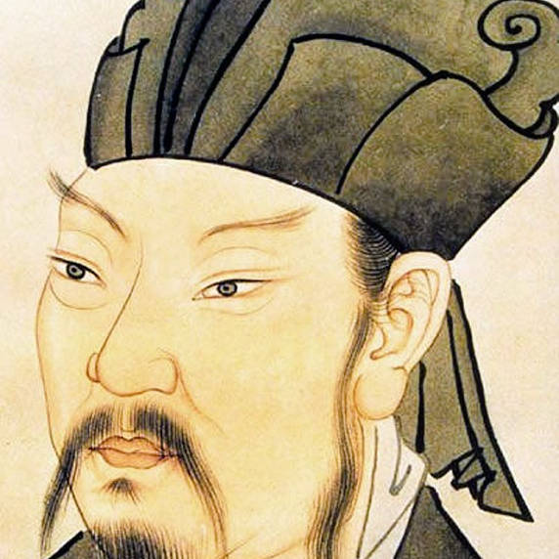](http://mp.sohu.com/profile?xpt=MzhiMzBmM2ItM2QwMC00ZjNiLTg5ZjYtZGRjZmJhNjYyOGZi&spm=smpc.content-abroad.fd-d.73.1674759585878nV5uGqQ)

[](http://mp.sohu.com/profile?xpt=ODdlMzZmMjMtN2ExYS00NjJhLTg5M2ItNWU5YTc5YTFjYWRk&spm=smpc.content-abroad.fd-d.77.1674759585878nV5uGqQ)

[](http://mp.sohu.com/profile?xpt=MzljNTI3YWMtNTE2OS00NTkxLWJiYWMtY2FlNDYzMmEwZWQy&spm=smpc.content-abroad.fd-d.80.1674759585878nV5uGqQ)

[[](https://mp.sohu.com/profile?xpt=YTZlNzZkZGItODY0Ni00MTg2LThmZTctYmRjZTdmMzYzMTZm&_f=index_pagemp_1&spm=smpc.content-abroad.author.1.1674759585878nV5uGqQ)](https://mp.sohu.com/profile?xpt=YTZlNzZkZGItODY0Ni00MTg2LThmZTctYmRjZTdmMzYzMTZm&_f=index_pagemp_1&spm=smpc.content-abroad.author.1.1674759585878nV5uGqQ" \t "_blank)

[墨染印画](https://mp.sohu.com/profile?xpt=YTZlNzZkZGItODY0Ni00MTg2LThmZTctYmRjZTdmMzYzMTZm&_f=index_pagemp_1&spm=smpc.content-abroad.author.1.1674759585878nV5uGqQ" \t "_blank)

[文章 477 总阅读 181万](https://mp.sohu.com/profile?xpt=YTZlNzZkZGItODY0Ni00MTg2LThmZTctYmRjZTdmMzYzMTZm&_f=index_pagemp_1&spm=smpc.content-abroad.author.1.1674759585878nV5uGqQ" \t "_blank)

[[](https://h5-ol.sns.sohu.com/hy-op-h5/operation/activity/201009002?subChannelId=sohu_M10000035&_f=index_betapagehotnews_2&spm=smpc.content-abroad.tw.2.1674759585878nV5uGqQ)2](https://h5-ol.sns.sohu.com/hy-op-h5/operation/activity/201009002?subChannelId=sohu_M10000035&_f=index_betapagehotnews_2&spm=smpc.content-abroad.tw.2.1674759585878nV5uGqQ)

[[](http://mp.sohu.com/profile?xpt=ZGRjNWI0NTAtMTYzZi00NTAzLWJmZGYtMWRmNWY4YTJkNDhl&spm=smpc.content-abroad.mp.4.1674759585878nV5uGqQ)](http://mp.sohu.com/profile?xpt=ZGRjNWI0NTAtMTYzZi00NTAzLWJmZGYtMWRmNWY4YTJkNDhl&spm=smpc.content-abroad.mp.4.1674759585878nV5uGqQ" \t "_blank)

[[](http://mp.sohu.com/profile?xpt=NDY5ZTQ1OTUtZDcwZS00OGNlLWJlNDQtMzcxYmQyMTViOWJi&spm=smpc.content-abroad.mp.6.1674759585878nV5uGqQ)](http://mp.sohu.com/profile?xpt=NDY5ZTQ1OTUtZDcwZS00OGNlLWJlNDQtMzcxYmQyMTViOWJi&spm=smpc.content-abroad.mp.6.1674759585878nV5uGqQ" \t "_blank)

[美女助教](https://www.sohu.com/a/634309661_121496984?scm=1102.xchannel:1553:110036.0.3.0~9000.8003.0.0.00&spm=smpc.content-abroad.mp.7.1674759585878nV5uGqQ" \t "_blank)

[[](http://mp.sohu.com/profile?xpt=MTUzNWM0NjYtMDViYi00YjQyLWEwNzgtYTI2NmY4NmZlODNk&spm=smpc.content-abroad.mp.8.1674759585878nV5uGqQ)](http://mp.sohu.com/profile?xpt=MTUzNWM0NjYtMDViYi00YjQyLWEwNzgtYTI2NmY4NmZlODNk&spm=smpc.content-abroad.mp.8.1674759585878nV5uGqQ" \t "_blank)

[[](http://mp.sohu.com/profile?xpt=MGEzYjAwNjAtZWFiZC00ZjlmLWE4ODAtNzUzM2ZlNTYyZmNm&spm=smpc.content-abroad.mp.10.1674759585878nV5uGqQ)](http://mp.sohu.com/profile?xpt=MGEzYjAwNjAtZWFiZC00ZjlmLWE4ODAtNzUzM2ZlNTYyZmNm&spm=smpc.content-abroad.mp.10.1674759585878nV5uGqQ" \t "_blank)

[[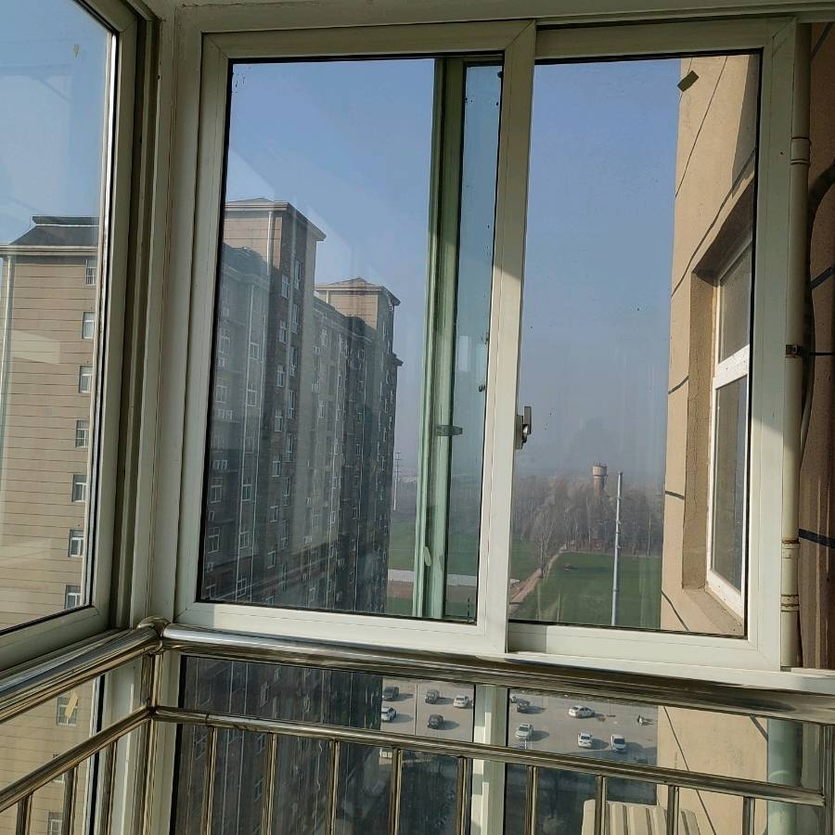](http://mp.sohu.com/profile?xpt=Mjg1YzdhNDYtNGQ0OC00YzVlLTk4ODItODhjMTE3NGE5YzY5&spm=smpc.content-abroad.mp.12.1674759585878nV5uGqQ)](http://mp.sohu.com/profile?xpt=Mjg1YzdhNDYtNGQ0OC00YzVlLTk4ODItODhjMTE3NGE5YzY5&spm=smpc.content-abroad.mp.12.1674759585878nV5uGqQ" \t "_blank)

[[](https://h5-ol.sns.sohu.com/hy-op-h5/operation/activity/201009002?subChannelId=sohu_M10000035&_f=index_betapagehotnews_2&spm=smpc.content-abroad.tw.2.1674759585878nV5uGqQ)2](https://h5-ol.sns.sohu.com/hy-op-h5/operation/activity/201009002?subChannelId=sohu_M10000035&_f=index_betapagehotnews_2&spm=smpc.content-abroad.tw.2.1674759585878nV5uGqQ)

[高颜值聊天交友，遇见就别错过！](https://h5-ol.sns.sohu.com/hy-op-h5/operation/activity/201009002?subChannelId=sohu_M10000035&_f=index_betapagehotnews_2&spm=smpc.content-abroad.tw.2.1674759585878nV5uGqQ)